# Installation manual ZET Compass

## Install Anaconda

1. Install latest version Anaconda via website
2. Open Anaconda navigator and go to environments
3. 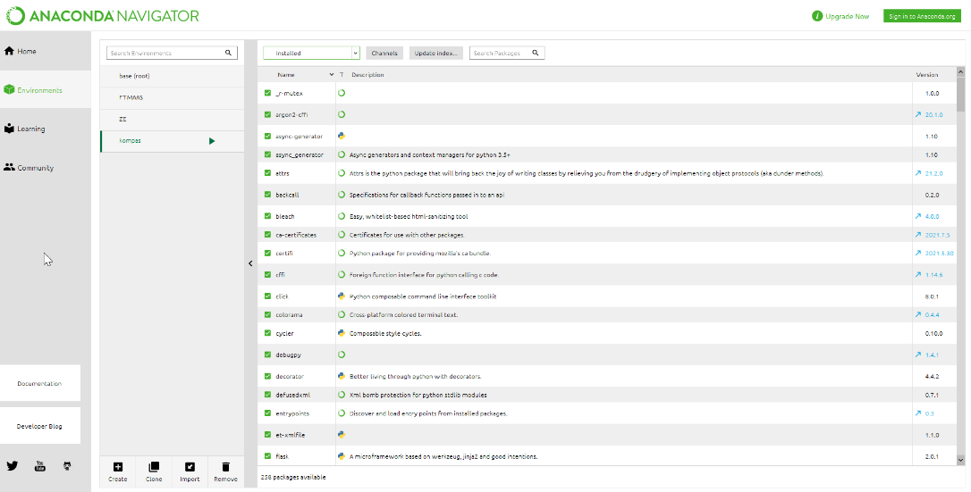Import kompas.yml from the folder where the transport kompas is located

1 . Screenshot of Anaconda navigator environment

1. Go to anaconda prompt and type *conda activate kompas*
2. Copy the path where the transport compass is located, for example C:\Users\<username>\Documents\transport_kompas
3. In Anacoda prompt, type  *cd <path to transport kompas>*
4. Run *python app.py*
5. Copy the html address and paste it into your web browser. You should now see a screen with a welcome screen and a link to the transport kompas documentation.

## Postman desktop

1. Install Postman Desktop via website
2. Login with your account and request access to the Transport Kompas project (you will receive an email for this)
3. Go to *environments/local test* in Postman Desktop
4. In local test adjust the paths under the tab *current value* so that they point to the correct file. Make sure that the / are in the right direction and that the extensions are correct (.xlsx or .xslm)
5. Here you can also indicate whether you want to compare scenarios or strategies and which scenario/strategy is being run and which company.
6. Save Local test in the top right corner
7. Go to *Collections/local excel* in Postman and in the top right under environments select local test
8. In local excel choose *send and download*
9. Wait for the tool to finish running and check the response html file.
10. If there is an error, check the last log file under the transport_kompas/logs folder for possible input errors and adjust it and repeat the last two steps.

*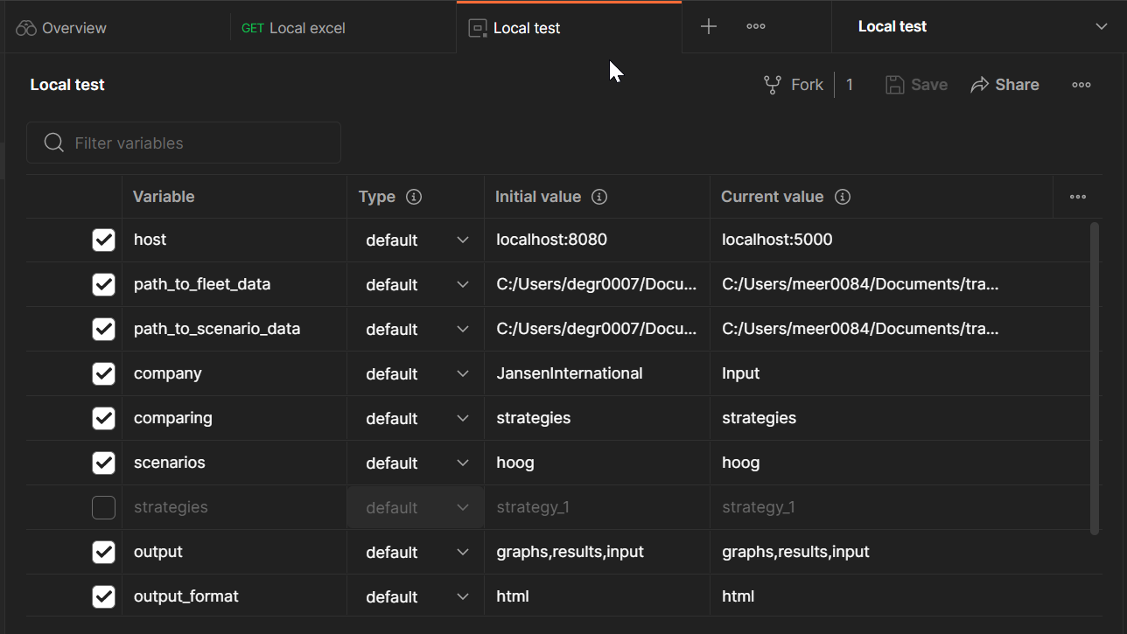2. Example of Postman environment.*